**Internals 1 :**

Q1. Design a HTML form to accept a string from the user. Develop a PHP function to check whether the given string is a palindrome or not. Also a PHP function to count the total number of vowels and consonants in the same string, then show the occurrences of each vowel also.

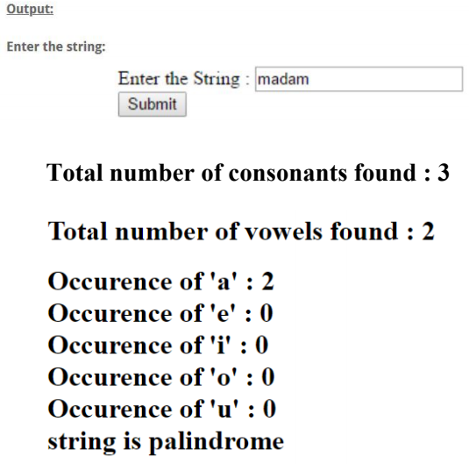

Q2: Design a HTML Form to create a menu to perform the following operations on a given associative array using

PHP Script:

I. Display the associative array

II. Insert a new element into the associative array

III. Count the number of elements in the associative array

IV. Delete an element from the associative array considering key and value individually

V. Sort the elements in the associative array using key and value individually

VI. Reverse the elements in the associative array

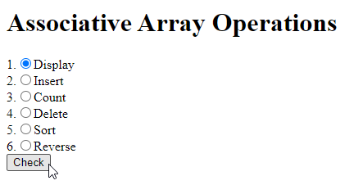

Q3: Design a HTML Form and PHP script to demonstrate inheritance and polymorphism to find the area of square, rectangle and circle. Create an interface ‘shape’ to include a method called area(). Implement this interface in square, rectangle and circle classes. Also create appropriate base class.

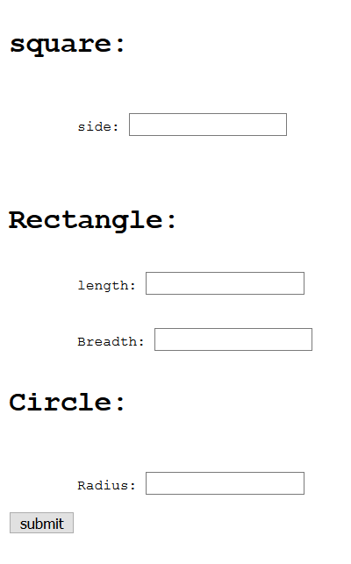

Q4: Design a HTML Form to accept the Students details. All the fields are

mandatory. Develop PHP script to display the student details.

Form Validation:

Name: maximum length 30 characters and must only contain letters and

whitespace

USN: 10 characters only and should be in USN format only like 1MS19MCA20

or 1MY19MCA03

e-mail: Must contain a valid email address (with @ and .)

Present Age: Make the present Age textbox disabled. Calculate the Present Age

from the DoB only.

Gender: Must select one

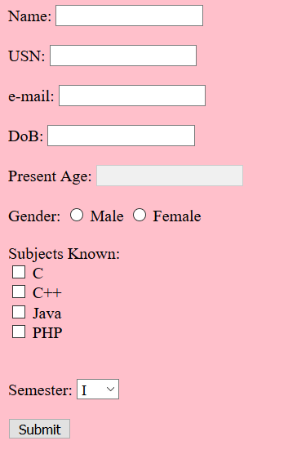

Q5: Design a HTML Form to accept numbers (minimum 20) from the user into a text box. Develop appropriate PHP functions to check how many numbers are entered, and how many are prime numbers, even numbers and odd numbers in that numbers entered.



**Output:**

**The Entered Numbers:**

**The count:**

**Number of Prime Numbers:**

**Number of Even Numbers:**

**Number of Odd Numbers:**

**Internals 2 :**

Q1. Develop a web application with appropriate fields and PHP

script to count the number of visitors to a particular web page

using **Cookies and Sessions**

**Q2.** Develop a web application with appropriate fields and PHP

script to count the number of visitors to a particular web page

using **Cookies and Sessions**

**Q3.** Develop Web Application using MySQL and PHP script to create

•**“Employee”** table with Emp_Id (Primary Key),

Emp_Name (Not Null), Dept_Name (Not Null), Salary (Not

Null)

•**“Department”** table with Dept_Id (Primary Key) and

Dept_Name (unique)

•Insert at least 5 rows into both Employee and Department

table by taking the user input through **HTML forms**.

•Display the department wise Emp_names using **HTML**

**table**

•Display Emp_names whose salary is greater than the

average salary of employees

•Delete the department, if there are less than 2 employees in that department

Q4. Develop Web Application using MySQL and PHP script to

create

•**“Employee”** table with Emp_Id (Primary Key),

Emp_Name (Not Null), Dept_Name, Age (Not Null)

•**“Department”** table with Dept_Id (Primary Key) and

Dept_Name (unique)

•Insert at least 5 rows into both Employee and Department

table by taking the user input through **HTML forms**.

•Display the Emp_names who work in more than one

department using **HTML table**

•Display Emp_names starting with letter **‘s’** or **‘S’**

•Delete the Emp_names, if they work for more than one department

Q5. Develop a web application using PHP and AJAX, to accept

the **username** in the **text field** and display the information from

the text file matching with the **first character** in the username

entered in the text field.

Hint. Create a text file with 10 records with Username and Age

Fields

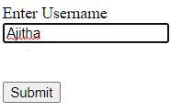

Output :



Ajitha 45

Arun 50



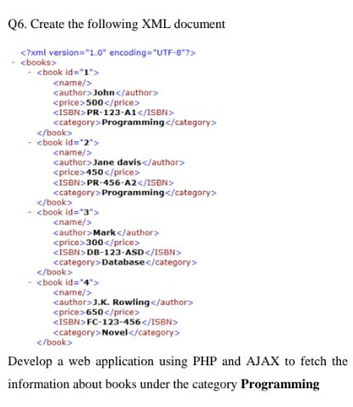

Q7. Develop a web application using PHP and AJAX, to accept

the **username** in the **text field** and display the information about

that user from the MySQL table **user**

Hint. Create a table **user** with fields Username and Age and insert

at least 5 records



Output :



Ajitha 45

Arun 50

